Structure and Functions of the Nervous System

- The nervous system is made up of many types of neurons, they all have specialized structures that enable them to convey electrical signals.
- The organs of the nervous system form two subsystems.

Central Nervous System (CNS): made up of the brain and the spinal cord and is the main
information processing center of the body.

Peripheral Nervous System (PNS): made up of all the nervous tissue outside the CNS.
The PNS delivers information to the CNS and carries messages from the CNS to other organs.

- Sensory Input: The PNS receives information about an environmental change, or
stimulus and sensory neurons carry the information about the stimuli to the CNS.

- Integration: The CNS interprets the information using interneurons.

- Motor Output: The CNS orders a response. These signals are carried away from the CNS by motor neurons.

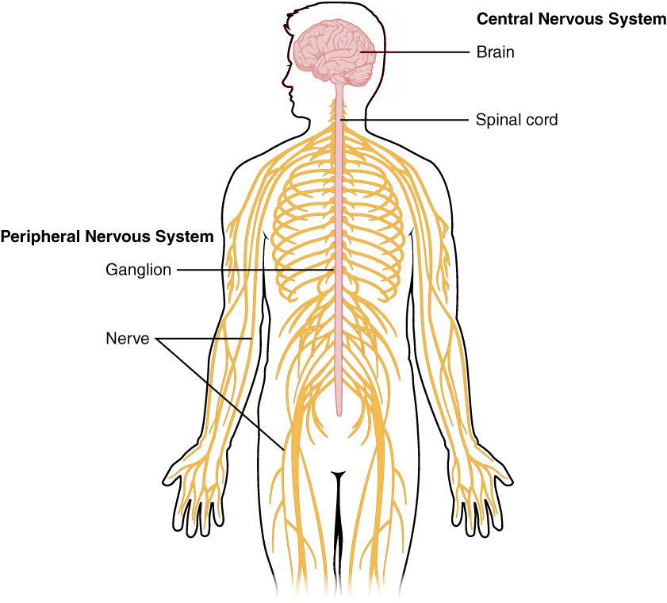
Nervous System Diagram

Central Nervous System (CNS)
Structure: Brain and spinal cord
Function: Integrative and control centers

Peripheral Nervous System (PNS)
Structure: Cranial nerves and spinal nerves
Function: Communication lines between the
CNS and the rest of the body.

Sensory (Input) Motor (output)
Structure: Sensory nerves Structure: Motor nerves
Function: Conducts impulses from Function: Conducts impulses from the CNS to
sensory receptors to the CNS effectors (muscles and glands)

Sympathetic Autonomic Nervous System Somatic Nervous System
(fight or flight response) (Involuntary responses) (Voluntary)

Parasympathetic
(homeostasis)

